Route

Route::middleware(['auth', 'admin'])->group(function () {

    Route::resource('siswa', SiswaController::class)->only('index', 'store', 'create', 'edit');

    Route::post('siswa/{id}', [SiswaController::class, 'update']);

    Route::get('hapussiswa/{id}', [SiswaController::class, 'destroy']);

    Route::get('export', [SiswaController::class, 'export']);

    Route::post('/logout', [LoginController::class, 'logout']);

});

Route::get('upload', [SiswaController::class, 'upload']);

Route::post('uploadimg', [SiswaController::class, 'uploadimg'])->name('uploadimg');

Route::get('user', [SiswaController::class, 'user'])->middleware(['auth', 'user']);

Route::get('filter', [SiswaController::class, 'filter']);

Auth::routes();

Route::get('/home', [App\Http\Controllers\HomeController::class, 'index'])->name('home');

Controller

<?php

namespace App\Http\Controllers;

use Illuminate\Http\Request;

use App\Models\Siswa;

use Illuminate\Support\Facades\Redirect;

use Yajra\DataTables\Facades\DataTables;

use App\Exports\SiswaExport;

use App\Models\Uploadimg;

use Illuminate\Contracts\Cache\Store;

use Maatwebsite\Excel\Facades\Excel;

use Illuminate\Support\Facades\File;

class SiswaController extends Controller

{

*/\*\**

*\* Display a listing of the resource.*

*\**

*\* @return \Illuminate\Http\Response*

*\*/*

    public function index(Request $request)

    {

        $awal = $request->awal;

        $akhir = $request->akhir;

        if ($request->ajax()) {

            if (!empty($awal)) {

                $aw = $awal . ' 00:00:00';

                $ak = $akhir . ' 23:59:00';

                $data = Siswa::whereBetween('created_at', [$aw, $ak])->get();

            } else {

                $data = Siswa::all();

            }

            return Datatables()->of($data)

                ->addColumn('action', function ($data) {

                    $btn = '<a class="btn btn-small btn-success" href="siswa/' . $data->id . '/edit"><i class="fas fa-pen"></i></a> <a class="btn btn-small btn-danger" href="hapussiswa/' . $data->id . '"> <i class="fas fa-trash"></i></a>';

                    return $btn;

                })

                ->rawColumns(['action'])

                ->addIndexColumn()

                ->make(true);

        }

        return view('siswa/tampil');

    }

    public function user()

    {

        return view('user');

    }

*/\*\**

*\* Show the form for creating a new resource.*

*\**

*\* @return \Illuminate\Http\Response*

*\*/*

    public function create()

    {

*//*

        return view('siswa/tambah');

    }

*/\*\**

*\* Store a newly created resource in storage.*

*\**

*\* @param  \Illuminate\Http\Request  $request*

*\* @return \Illuminate\Http\Response*

*\*/*

    public function store(Request $request)

    {

*//validasi yang mau apa saja yg mau di insert*

        $validated = $request->validate([

            'nama' => 'required',

            'alamat' => 'required',

            'usia' => 'required',

            'nohp' => 'required',

            'sekolah_id' => 'required',

        ]);

        $data = Siswa::create($validated);

        return redirect('siswa')->with('success', 'Data Berhasil Masuk');

    }

*/\*\**

*\* Display the specified resource.*

*\**

*\* @param  int  $id*

*\* @return \Illuminate\Http\Response*

*\*/*

    public function show($id)

    {

*//*

    }

*/\*\**

*\* Show the form for editing the specified resource.*

*\**

*\* @param  int  $id*

*\* @return \Illuminate\Http\Response*

*\*/*

    public function edit($id)

    {

*//*

        $data = Siswa::find($id);

        return view('siswa/edit', compact('data'));

    }

*/\*\**

*\* Update the specified resource in storage.*

*\**

*\* @param  \Illuminate\Http\Request  $request*

*\* @param  int  $id*

*\* @return \Illuminate\Http\Response*

*\*/*

    public function update(Request $request, $id)

    {

*//*

        $data = Siswa::findOrFail($id);

        $validated = $request->validate([

            'nama' => 'required',

            'alamat' => 'required',

            'usia' => 'required',

            'nohp' => 'required',

            'sekolah_id' => 'required',

        ]);

        $data->update($validated);

        return redirect('siswa')->with('success', 'Data Berhasil di ubah');

    }

*/\*\**

*\* Remove the specified resource from storage.*

*\**

*\* @param  int  $id*

*\* @return \Illuminate\Http\Response*

*\*/*

    public function destroy($id)

    {

*//*

        $data = Siswa::findOrFail($id);

        $data->delete();

        return redirect('siswa')->with('success', 'Data Berhasil di hapus');

    }

*// public function filter(Request $request)*

*// {*

*//     $awal = $request->awal . ' 00:00:00';*

*//     $akhir = $request->akhir . ' 23:59:00';*

*//     if ($awal == $akhir) {*

*//         $data = Siswa::whereDate('created_at', $awal)->get();*

*//     } else {*

*//         $data = Siswa::whereBetween('created_at', [$awal, $akhir])->get();*

*//         // }*

*//         return Datatables::of($data)->make(true);*

*//     }*

*// if ($request->ajax()) {*

*//     return Datatables::of($d)*

*//         // ->addIndexColumn()*

*//         ->addColumn('Action', function ($d) {*

*//             $actionBtn = "<button class='btn btn-success'><i class='fas fa-pen' id='" . $d->id . "'></i></button>";*

*//             $actionBtn .= "<button class='btn btn-danger'><i class='fas fa-trash' id='" . $d->id . "'></i></button>";*

*//             return $actionBtn;*

*//         })*

*//         ->rawColumns(['Action'])*

*//         ->make(true);*

*// }*

*// }*

    public function export()

    {

        return Excel::download(new SiswaExport, 'users.xlsx');

    }

    public function upload()

    {

        $data = \App\Models\Uploadimg::all();

        return view('upload', compact('data'));

    }

    public function uploadimg(Request $req)

    {

        $validator = $req->validate(

            [

                'image' => 'required|image'

            ]

        );

        if ($req->file('image')) {

            $validator['nama'] = $req->file('image')->store('img');

        }

*// dd($validator);*

        $data = Uploadimg::create($validator);

*// return $req->file('image')->store('img');*

        return redirect('upload');

    }

}

1 Membuat model dan migrate sesui gambar di bawah

barang

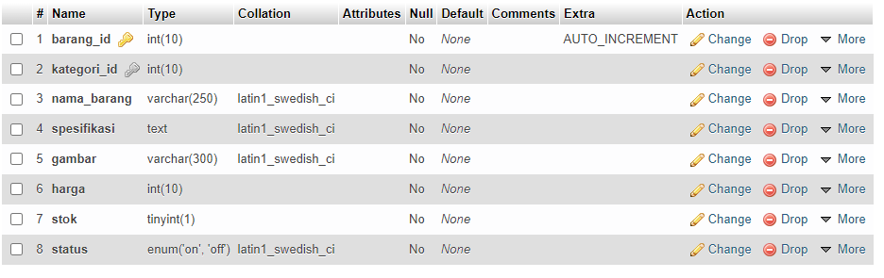

Kategori

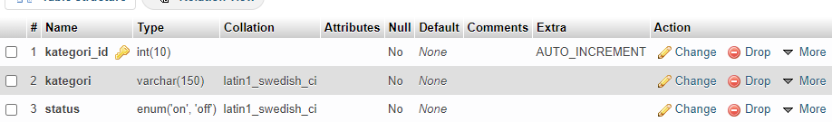

User

